
MathWorks® Hackathon
Signal Decryption Challenge

Instructions for Getting Started

This guide provides detailed, step-by-step instructions to help your team use MATLAB® for decrypting audio signals. It also includes a list of references that you can consult for inspiration while developing your own solution to the challenge.
Good luck!

Table of Contents
Getting Started 3
Challenge Statement 3
Getting Started with MATLAB 3
Resources 4
Example Model 4
Submitting your Results 4

Getting Started

Challenge Statement
This challenge is designed to help you build core signal processing skills while experiencing the excitement of decrypting hidden audio messages. You will work with Dual-Tone Multi-Frequency (DTMF) signals—commonly used in telephone systems—to decode passwords and uncover secret messages.
You are encouraged to explore this repository: Signal Processing Adventures: From FFT to Spectrograms and Filters. It is optional to start with the five experiments in that repository, but they may help you develop the skills to tackle the hackathon.
To save time, you can choose to begin the challenge directly by selecting one trial from the repository and completing it by following the steps outlined below. If you skip the experiments for this event, we recommend going through them after the hackathon to continue learning and to explore signal processing further.

🧭 Getting Started (Optional)
- Complete the five experiments in the Signal Processing Adventures: From FFT to Spectrograms and Filters repository, or
- Review the examples in the Resources section of this documentation
Or, to jump right in:
  - Open the starter.mlx, select a trial, and follow the steps.
✅ Challenge Steps
- Read the Password Audio File
Load the password audio file from your selected trial into MATLAB.
- Visualize and Analyze DTMF Signals
Use the Signal Analyzer app or MATLAB code to analyze the DTMF tones.
Each keypress generates two tones (row + column) based on the following frequency table:
 | 1209Hz | 1336Hz | 1477Hz | 1633Hz
697Hz | 1 | 2 | 3 | A
770Hz | 4 | 5 | 6 | B
852Hz | 7 | 8 | 9 | C
941Hz | * | 0 | # | D
- Decrypt the Password
Use the Signal Analyzer, MATLAB code, or a Simulink model to extract the 11-character password from the DTMF signal.
- Unlock the Secret Audio File
Unzip the Secret folder in the same trial and enter the decrypted password when prompted to access the secret audio file.
  - Reveal the Secret Message
Apply signal processing techniques (e.g., filtering, spectral analysis) to extract the hidden message using the Signal Analyzer app or MATLAB code.
  - Get your diploma for passing the Trial
Use the Trial.mlx script in the Signal Processing Adventures: From FFT to Spectrograms and Filters repository to check the message you decrypted and claim your membership diploma in the Fellowship of the Signal!
  - Go Further (Optional)
Build a scalable solution using MATLAB functions or Simulink to automatically decode DTMF passwords

Getting Started with MATLAB
- Create a MathWorks account
- Go to https://www.mathworks.com/
- Click ‘Sign In’ in the upper right corner of the page
- Click ‘Create Account ‘

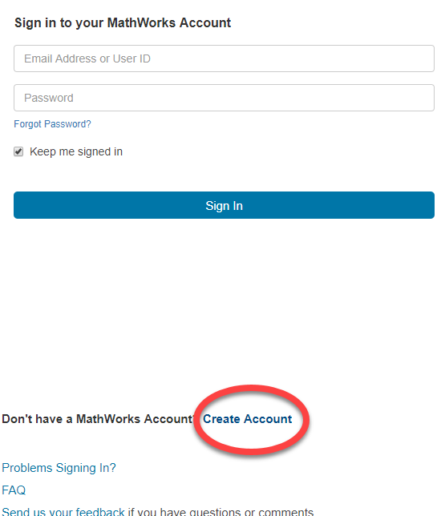
- Fill out the page and then press ‘Create’
- Access MATLAB Online
- Go to https://matlab.mathworks.com/
- Log in Using MathWorks account

Resources
The MathWorks ‘Awesome MATLAB Hackathons’ GitHub repository offers a wide range of resources to help you get started with various topics.
https://github.com/mathworks/awesome-matlab-hackathons
For this challenge, you may also find the following examples helpful when developing your own solution:
- Signal Analysis and Visualization – Learn how to use the Signal Analyzer app
- Practical Introduction to Time-Frequency Analysis – Understand what DTMF signaling is and how to analyze DTMF signals in time and frequency
- DFT Estimation with the Goertzel Algorithm – Efficiently detect DTMF tones using the Goertzel algorithm
- Design Peak and Notch Filters – Learn how to design filters to isolate or remove specific frequencies
- DTMF Generator and Receiver – Explore Simulink models for generating and decoding DTMF signals

Submitting your Results
Once you have completed your work, you must prepare a submission that includes the passwords for all trials, the secret message your team has decoded, and your membership diploma in the Fellowship of the Signal (generated by the Trial.mlx script), along with your code or models. You may be required to give an in-person or recorded presentation to explain your solution.
Teams are encouraged to refer to the grading rubric provided in the event materials and to be creative in how they present their results. Further details on submission procedures will be shared with teams during the event.

